**Shahjalal University of Science and Technology, Sylhet.**

**Department of Computer Science and Engineering**



Thesis Writing Manual

March 2015

**Sequence of Sections**

1. Front Cover

2. Spine

3. Title Page

4. Recommendation Form by Thesis Advisor

5. Qualification Form of Bachelor Degree

6. Abstract

7. Acknowledgements or Preface

8. Table of Contents

9. List of Tables

10. List of Figures

11. Illustration of Symbols

12. The Text

13. References

14. Appendices

**Specifications**

**1. Paper size:** Write your thesison A4 size paper (210mm×297mm). As the front and back covers, please use thick hard paper, whose color should be black. The binding should be hard binding. (Spiral binding is not acceptable for final presentation).

**2. Spine:**Your thesis report has to be bound on the left side. The font is Times New Roman. This will include the department name (font size 12), thesis title (font size 16), student’s name (font size 12), month and year (font size 12).

**3. Fonts:**If you have to write Bangla text, use Vrinda font whose size should be matched (not same) with the English text for best look. When producing pdf, embed Bangla as well as the non-standard fonts. English font should be Times New Roman. The font size of general content should be 11 and line spacing should be 1.5.

**4. Margin:** The top and the bottom margins are 4 cm; the left and the right margins are 3 cm.

Put the page number at 1 cm from the bottom edge of the typing area and centered on the page.

**5. Front cover:**It includes school name, department name, degree, Thesis title, student’s name, adviser’s name, date.

**6. Title Page:**This page includes Thesis title, student’s name, adviser’s name, school name, department name, degree, date.

**7. Recommendation Form by Thesis Adviser:** This document, which is not mandatory, isspecified by your department.

**8. Qualification Form of Bachelor Degree:** See in sample format.

**9. Abstract:** The content of the abstract should indicate the purpose, sources, methods andresults, etc. And, there must be three to fifteen keywords. The abstract in English should not exceedonepage. You can use separate page for keywords.

**10. Acknowledgements (If needed):** This section should not exceed one page.

**11. Table of Contents:** This section needs to exhibit the page numbers of Abstract, Acknowledgements, Table of Contents, List of Tables, List of Figures, Illustration of Symbols, Headings for each chapter, References, and Appendices.

**12. Page Number Format:**

(1) From Abstract to List of Tables/Figures: These page numbers should be numbered consecutively in lower-case Roman numerals (i, ii, iii….).

(2) From Chapter 1 to Appendices: These page numbers should be numbered consecutively in English numerals (1, 2, 3….).

**13. List of Tables/Figures:** Tables and figures in your report are numbered and are represented by the notations, “Table No.” and “Figure No.”, respectively. For example, “Table 1.”, “Table 2.”, “Figure 1.”, “Figure 2.”

**14. References:** According to the academic convention, please use appropriate style for your report or dissertation such as APA, MLA, or IEEE.

**Writing Rules**

**1. Table of Contents:** Organize your report according to the sequence of sections.

**2. List of Tables/Figures:** Tables or figures in your report should be numbered consecutively and should be exhibited in the same section as the text regardless of sections or chapters.

**3. Illustration of Symbols:** The scientific symbols in your thesis/dissertation should be exhibited and illustrated within one page. All symbols do not have to be numbered.

**4. The Text:**

**(1) Section Symbol:** The segment number is denoted as two English numerals connected with a dot, such as “1.1”, “1.2”, “1.3”, “2.1”, “2.3”,” 2.3”, etc.

**(2) Section Name and Paragraph Levels:**

**(A)** The chapter number and name is at the top center of the typing area.

**(B)** The section number and the paragraph number are written at the beginning of a row. Write the section name and the paragraph name after one or two blank characters.

**(C)** The sub-paragraph number and name should be indented by one or more blank characters to distinguish the level.

**(3) Line Spacing:** Use 1.5 times the line height. (The chapter name uses 2 times the line height.)

**(4) Letter Spacing:** Choose the standard spacing in MS Word.

**(5) Mathematical Formula:** Order mathematical formulas consecutively. For example:

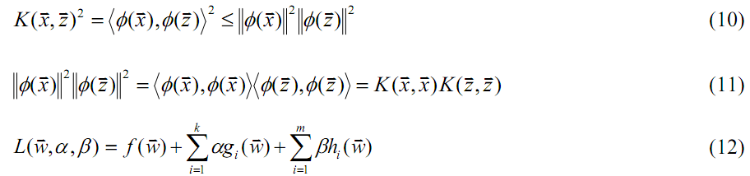

**(6) Footnote:**

**(A)** Use footnotes to explain special events or arguments.

**(B)** Footnotes in the same chapter are consecutively numbered and the number ismarked on the top right corner of the relevant text. Footnote numbers in thedifferent chapters do not follow each other. Number and content of footnotes arewritten at the bottom on the same page and can be written on the next page if thelayout is not enough. For example,

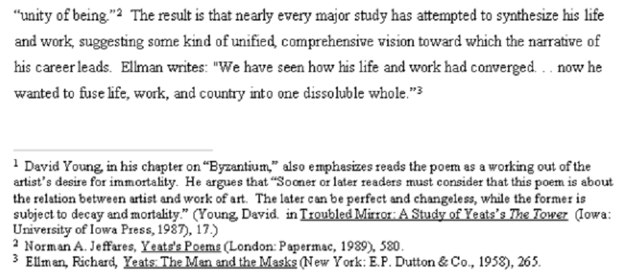

**(7) Tables and Figures Format:** The table number and name is placed on the top of the table; the figure number and name is placed on the bottom of the figure. Data sourcesand description should be placed on the footnote.

**5. Appendices:** While there are a large number of data, derivations, comments, or other lengthy works, please separate them into appendices.

Appendix 1 Sample Format of the Spine and Page layout

**Sample Format of Thesis/Dissertation Spine**



**Sample Format of the thesis report page layout**

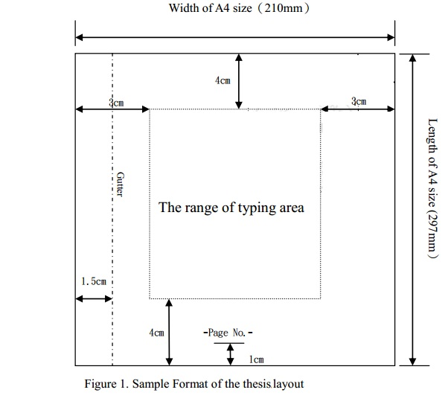

Appendix 2 Sample Format of Cover Page

Shahjalal University of Science and Technology18

Department of Computer Science and Engineering16



Thesis/Project Title16

Student: (Name, Reg. no, Year/Semester, Dept.)

Adviser: (Name, Designation,Dept.)

23rd March, 201516

Appendix 3 Sample Format of Title Page

Thesis/Project Title16



A Thesis/Project submitted to the Department of Computer Science and Engineering,

Shahjalal University of Science and Technology, in partial fulfillment of the requirements

for the degree of Bachelor of Science in Computer Science and Engineering.12

Student: (Name, Reg. no, Year/Semester, Dept.)

Adviser: (Name, Designation,Dept.)

23rd March, 201516

Appendix 4 Sample Format of Recommendation Form by Thesis Supervisor(not mandatory).

Recommendation Letter from Thesis Supervisor16

This Student,…………………., whose thesis entitled……..………., is under my supervision and agree to submit for examination.

Advisor ：

Date ：dd / mm / yyyy

Appendix 5 Sample Format of Qualification Form of Bachelor Degree

Qualification Form of Bachelor Degree16

Student Name： ____________________________________

Thesis Title： ______________________________________

This is to certify that the thesis submitted by the student named above in March, 2015. It is qualified and approved by the Thesis Examination Committee.

|  |  |  |
| --- | --- | --- |
| Head of the Dept. | Chairman, Thesis Committee | Supervisor |

Appendix 6 Sample Format of Abstract

ABSTRACT16

The abstract summarizes the content of the thesis, stating the problem being examined, the procedure or methods used, and any conclusions that are drawn.11

**Keywords**12**：**

Appendix 7 Sample Format of Acknowledgements

Acknowledgments16

Appendix 8 Sample Format of Table of Contents

TABLE OF CONTENTS

Page

Abstract i

Acknowledgement ii

table of contents iii

LIST OF TABLES i.

LIST OF FIGURES .

Illustration of Symbols vi

Abstract vii

1INTRODUCTION 3.

1.1 Background 3

1.2 Motivation 3

2 BACKGROUND STUDY 3.

3 METHODOLOGY 3

3.1 Chapter Headings 3

4 THE FOURTH CHAPTER 3

4.1 Section One 3

4.2 Section Two 3

5 NEW CHAPTERS 3

5.1 Updating the Table of Contents 3

6 EXPERIMENTAL STUDY 3

6.1 3

7 RESULT ANALYSIS AND DISCUSSIONS 3

7.1 3

8 CONCLUSION 3

8.1 Conclusion 3

8.2 About the Future Research 3

REFERENCES 3.

Appendices 3.

Appendix 9 Sample Format of List of Tables

List of Tables

**Page**

|  |  |  |
| --- | --- | --- |
| Table 1 | Classes of Computer System | 30 |
| Table 2 | Classes of Database System | 31 |
| Table 3 | …………………………… | 32 |
| Table 4 | …………………………… | 33 |
| Table 5 | …………………………… | 34 |
| Table 6 | …………………………… | 35 |

Appendix 10 Sample Format of List of Figures

List of Figures

**Page**

|  |  |  |
| --- | --- | --- |
| Figure 1 | Cloud Computing System | 30 |
| Figure 2 | Cluster System | 41 |
| Figure 3 | …………………………… | 42 |
| Figure 4 | …………………………… | 53 |
| Figure 5 | …………………………… | 54 |
| Figure 6 | …………………………… | 66 |

Appendix 11 Sample Format of Illustration of Symbols

Illustration of Symbols

LPC: Low pressure compressor (Booster tip)

HPC: High pressure compressor (Booster hub)

LPT: Low pressure turbine

HPT: High pressure turbine

VABI: Variable-area bypass injectors

MAPSS: Modular aero-propulsion system simulation

GUI: Graphic user interface

CLM: Component level model

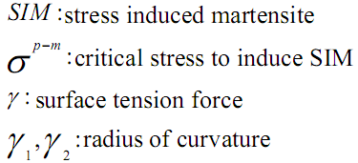

Appendix 12 Sample Format of the Text

**Chapter 1**

## INTRODUCTION16

The introduction is important because it clarifies the subject matter of the thesis, in order to let the reader know what the rest of the paper is about. One of the things that it should do is let the reader know why this particular subject is discussed. How is it important to the reader, the writer, and the audience or world in general?11

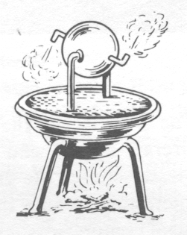

1. Heron’s Reaction Engine

### 1.1 Background12

Another important function of the introduction is to serve as an itinerary for what will follow in the main body of the thesis. It gives a step-by-step look at how the information will be given. A literature review is often included in this section to update the reader on the knowledge that was already available on this subject. (Notice how the pages are numbered differently on the first page of each chapter and the succeeding pages.)



1. Comparison of Linear and Nonlinear Controllers

### 1.2The Second Section

A literature review is often included in this section to update the reader on the knowledge that was already available on this subject. Sometimes, especially in a doctoral dissertation, an entire chapter may be necessary for the literature review.

### 1.3The Third Section

New sections start at the top of a page or are automatically spaced two spaces down from the previous section when you enter the style “Heading 3.”

#### 1.3.1Subsection One

The preliminary sections (Nomenclature, List of Tables, and List of Figures) are entered under “Heading 1” in styles because they use 14 point font and appear at the top of the page. Chapter numbers (CHAPTER II) are entered at the beginning of each new chapter under the style “Chapter numbers.” This heading keeps them in 12 point font, Bold, and automatically 3 inches down the page, without having to individually enter each line, and hope that it is three inches down. Next, hit “ENTER” and use style “Heading 2,” which will keep the same font, but is entered into the Table of Contents (TOC). The following type on the “ENTER” key puts your text two lines down for the chapter.

#### 1.3.2Subsection Two

As mentioned above, each section (1.1, 1.2, etc.) is entered as “Heading 3,” with a built-in spacing of two spaces before and one space after, as well centering on the line. The subsections are entered as “Heading 4” with only one space before and one after. It is Aligned Left, so that it can be separated from the section headings at a glance. “Headings 1-4” are each entered into the TOC, with the correct spacing and fonts built in for that also. The titles on the first preliminary page and the abstract are entered under the style “Title,” so that they do not appear in the TOC. A subsection that is even lower than one such as this one (1.3.2), that would not appear in the TOC is entered under “Heading 5,” and is in Italics and underlined. Normal text is “Body Text,” which means it is 12 point font, justified, double-spaced, with an automatic first line indentation when you hit “Enter.” Any text, especially in the preliminary pages, which need to be centered on the page are entered as “approval,” as the Approval form is entered. However, nothing else should need to be centered in that way.

Chapter 2

Background Study

## chapter 3

## Methodology

This chapter is the beginning of the real meat of the paper. It deals with methods or procedure, as well as the results. Be sure to include tables and figures wherever they are needed to describe parts, methods, tests, results, or anything else that applies to the subject matter. Thoroughly describe all tables, figures, or graphs included, so they can be applied directly to the subject matter.11

### 2.1Figures and Tables

Figures and tables should be easily “readable without relying on the accompanying description in the text” [2].

### 2.2Section about Equations

Putting equations into the text is somewhat trickier than regular text. Most equations should be entered from an outside source, such as Equation Editor or MATHTYPE. When entering an equation, use the style “equation,” which automatically indents it one inch for you to add your equation. After the equation has been added, hit the “Tab” key, which will move you to “align right,” where you can enter the equation number in parentheses. After your equation, hit enter to begin the next paragraph.

 (2.1)

When an equation, figure, or table is included in your text, always explain them either before, after, or both. The following insert is from another paper, and includes a figure and equations, with explanations of each.

A block diagram of the controller used in MAPSS is shown in Figure 3. The error signal into the controller is represented by

 (2.5)

and the control signal out of the controller is represented by

. (2.6)

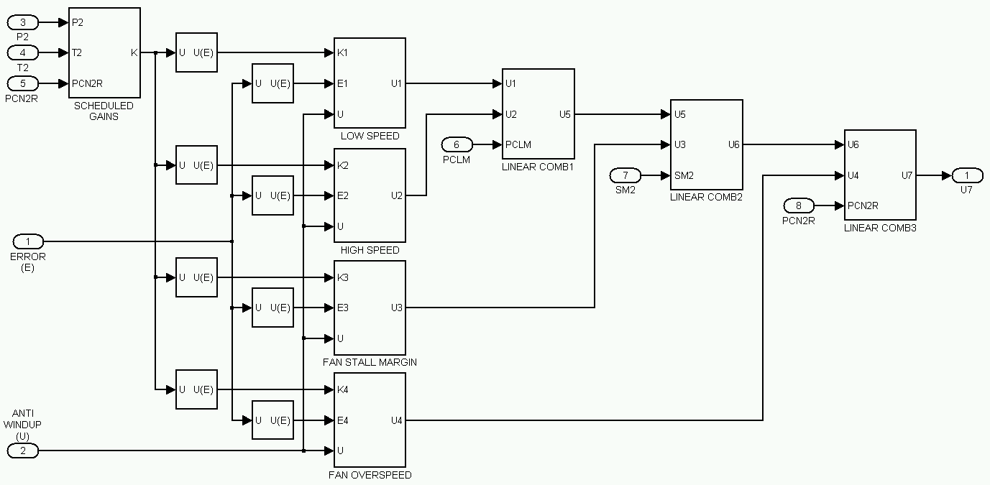

1. The Controller

### Importing and Exporting Styles

You may want to import styles from one document to another, possibly to fix up an old document or just so you don’t have to recreate your favorite styles. Here is an example of how to import the styles from one document into another document.

1. Open the document that you want to export the styles from and save it as a (.dot) template file. Word will automatically save it in the default template location.
2. Close the file.
3. Open the document that you want to import the styles into.
4. Click **Tools** then **Templates and Add-Ins** on the tool bar.
5. Click the **Attach** button; locate and highlight the **(exported file).dot** created in Step 1 and click **Open**.
6. Check the **Automatically update document styles** checkbox and click **OK** to close the window.
7. Again click **Tools** then **Templates and Add-Ins** on the tool bar.
8. Uncheck the **Automatically update document styles** checkbox and click **OK** to close the window.
9. Go through the document highlighting various parts and selecting the new styles for them.
10. Delete any old styles that still remain.

## 

## 3 THE THIRD CHAPTER

Each chapter must have a title which is centered and capitalized. Be sure to come up with a title which fits your chapter information. Unfortunately, “The Third Chapter” is not a good title for a technical paper. Make sure you capitalize all letters in the chapter title, or they will not appear that way in the TOC.

### 3.1Chapter Headings

The style “Chapter Number” begins three inches down from the top of the page. Hit “ENTER” and then enter the style “Heading 2,” which will automatically enter two lines. The other pages have a one-inch margin at both top and bottom. [1]

Unlike this chapter, your chapters should always have more than one section. If you are going to have a section 3.1, you should also have a section 3.2. In the same way, if you have a subsection 3.1.1, you should also have a subsection 3.1.2. If you only have one section or subsection, consider using “Heading 5” instead. This will underline it and put it in Italics, but will not put it in the TOC.

##### The Single Section

This is what “Heading 5” looks like, to be used for a single section or subsection, or for a section under the subsection.

## 4 THE FOURTH CHAPTER

Any direct quotations three or more lines in length are indented five spaces from both the right and left margins and single-spaced. These quotations do not need to be in quotation marks. Be sure to cite any direct or indirect quotations to the material it originally came from. Avoid copyright infringement.

### 4.1Section One

The Appendix section is used for materials that are not absolutely necessary to the paper , but help to make the thesis more complete.

### 4.2Section Two

Special paper must be used in the final copy that is to be submitted for approval. Refer to the Format Guidelines for more information about it.

## 5 MAKING NEW CHAPTERS

Each chapter should begin with a section break, which you can make by going into “File,” and “Page setup.”

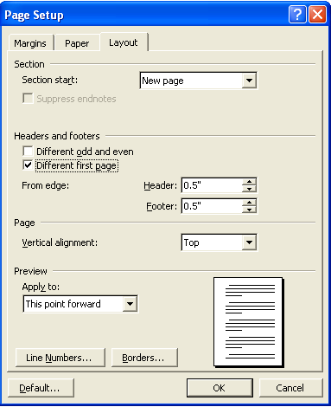

1. Page Setup View

As illustrated in the figure above, the Section Start should be set as “New Page.” In the Headers & Footers section, check “Different first page.” The Preview section should be applied to “This point forward.”

To delete page breaks, go into “View,” and click on “Normal.”

### 5.1 Updating the Table of Contents

When you finish your paper, and at some points during the writing of it, update the Table of Contents. Right-click on any line of the DOC page, and click on “Update Field.” This will input whatever you have as Headings 1,2,3, and 4. This is the same method used for updating the List of Figures and the List of Tables.

An important thing to remember and the last thing you should do before printing out any version of the paper is the extra editing for the TOC. It does not automatically have a Roman numeral in front of the chapter title, but it needs to have this. So, before each chapter title, put the Roman numeral that corresponds to it (i.e., I. Introduction), followed by 4 spaces. These numbers will show up in blue with an underline. To edit this, highlight the insertion and right-click on it. Click on “Font,” and where the color is blue, change to automatic in the drop-down box. Change the underline beside it to “(none).” You will need to do this to each chapter’s Roman numerals in the TOC.

## 

## 6 MORE ABOUT TABLES AND FIGURES

When entering a figure into your paper, begin by saving the figure as a “.tif” file because Word compresses these better than any other files. The place where you will insert the figure should be set as style “figure,” This will automatically center the figure, and follow it with the style “figure caption,” where you enter the title of the figure. Then insert the figure by going to “Insert,” “Picture,” and “From file.”

Entering tables into your paper is similar, although the table is inserted under style “Table Grid.” Notice that “Table I: Table head” where you enter the table name, precedes the table, unlike with normal figures in this paper. The following insertion from a dissertation proposal illustrates what the table should look like. Note that the style of the first row of words “table col head,” meaning the column heads of the table. The rest of the words in the table are written under the style of “table copy,” which is generally basic print.

Table 1 lists tentative dates for the eight proposed milestones to be carried out.

1. Research Plan

|  |  |  |  |
| --- | --- | --- | --- |
| Step | Description | Start Date | End Date |
| 1. | Create a method of identifying the relative gain *B* | 09/13/2004 | 11/28/2004 |
| 2. | Create a method of identifying the relative order *n* | 09/13/2004 | 11/28/2004 |
| 3. | Determine *n* and *B* at a single operating point | 11/29/2004 | 01/16/2004 |
| 4. | Design a new regulator at a single operating point | 11/29/2004 | 01/16/2004 |
| 5. | Test the regulator and compare it with the current one | 01/17/2005 | 01/31/2005 |
| 6. | Design the regulator for a range of operating points | 02/01/2005 | 04/10/2005 |
| 7. | Design new regulators for the other three existing | 04/11/2005 | 05/15/2005 |
| 8. | Develop an alternate method of blending if needed | 05/16/2005 | 06/10/2005 |

## 

## 7 CONCLUSION

The purpose of the conclusion is to tie everything together that has been written in the paper so far. However, since this is just a template, the rules will be slightly different for this paper.

There are many strict guidelines that must be followed for the thesis to be accepted by the College of Graduate Studies. The best way to ensure all rules are being followed, refer to the “Format Guidelines” that are supplied by the College of Graduate Studies.

### 

### 7.1 About References

The references in paper are very important because it gives credit where credit is due. In other words, you are not plagiarizing and therefore, will not get into a lot of trouble with the college. The format for your dissertation should be in the order that it appears in your paper. For example, reference [1] in the References section is also the first one mentioned. Note that the reference number in the text above is in brackets. The order in each reference is:

1. First and Last Name, “Title of Paper,” *Publication*, pages, location, date or year.
2. Zhiqiang Gao, “On Discrete Time Optimal Control: A Closed form Solution,” Proc. of the 2004 American Control Conference, pp. 52-58, Boston MA, June 30-July 2, 2004.

The above #2 was an example of a reference from a paper. Notice that the commas go inside the quotation marks. Not every reference will be exactly like this one because not all references are technical papers. To review the correct style for the different type of references, visit the IEEE website mentioned in the Reference section of this paper.

### 7.2 About the Future Research Chapter

There is often another chapter that follows the Conclusion, called “Future Research.” This chapter is necessary for a thesis or dissertation because it leaves room for more to be done about your topic, possibly things that you would have liked to do with it, but did not have the time or resources. But it allows other students or professors to continue with your work in other areas that might help the future of your thesis. I hope this template is helpful to all who use it, allowing you to spend less time worrying about the format, and more time on the content of your thesis or dissertation.

Appendix 13 Sample Format of References

References

[1] R. E. K alman, “New results in linear filtering and predi ction theory,” J. Basic Eng., ser.

D, vol. 83, pp. 95-108, Mar. 1961.

[2] J. U. Buncombe, “Infrared navigation—Part I: Theory,” IEEE Trans. Aerosp. Electron. Syst.,

vol. AES-4, pp. 352–377, Sept. 1944.

[3] R. L. Myer, “Parametric oscillators and nonlinear materials,” in Nonlinear Optics, vol. 4, P.

G. Harper and B . S. Wherret, Eds. San Francisco, CA: Academic, 1977, pp. 47-160.

[4] M. Abramowitz and I. A. Stegun, Eds., Handbook of Mathematical Functions (Applied

Mathematics Series 55). Washington, DC: NBS, 1964, pp. 32-33.

[5] E. E. Reber, R. L. Michell, and C. J. Carter, “Oxygen absorption in the earth’s

atmosphere,” Aerospace Corp., Los Angeles, CA, Tech. Rep. TR-0200 (4230-46)-3, Nov.

1988.

[6] J. H. Davis and J. R . Cogdell, “Calibration program for the 16-foot antenna,” Elect. Eng.

Res. Lab., Un iv. Texas, Austin, Tech. Memo. NGL-006-69-3, Nov. 15, 1987.

[7] Transmission Systems for Communications, 3rd ed., Western Electric Co., Winston-Salem, NC,

1985, pp. 44–60.

[8] Motorola Semiconductor Data Manual, Motorola Semiconductor Products Inc., Phoenix, AZ,

1989.

...

...

...

...

...

...

...

...

...

...

...

...

...

...

Appendix 14 Sample Format of Appendices (Just for reference, not mandatory)

Appendix

.

.

.

.

.

.

.

.

.

.

.